ContactManagement_Verify Contact notes _Instance44_12-Jul-2018_07-49-08_AM_VerifyingAllNotesofanindividual.png

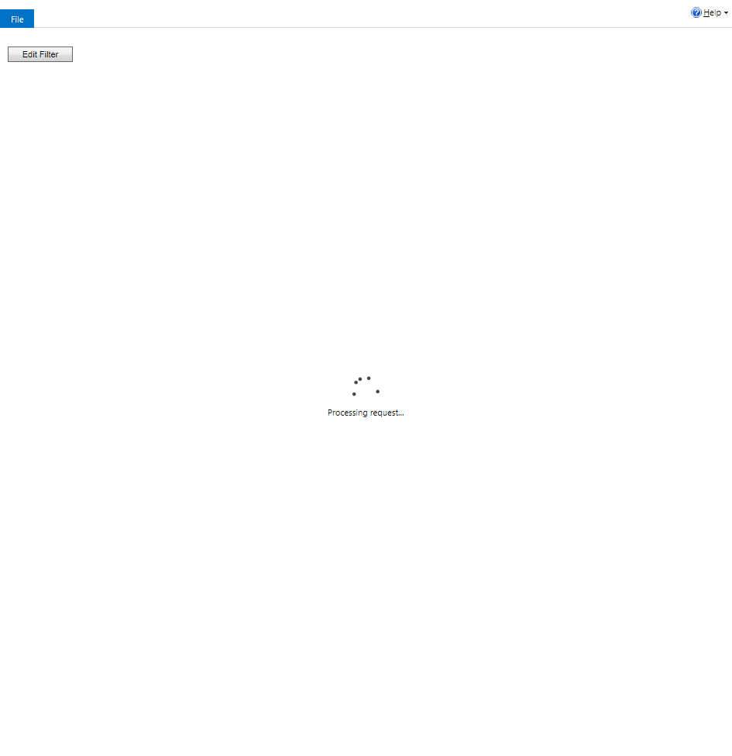

ContactManagement_Verify Contact notes _Instance44_12-Jul-2018_07-47-04_AM_MouseClickActiononStaleElement.png



ContactManagement_Verify Contact notes _Instance44_12-Jul-2018_07-47-07_AM_MouseClickActiononStaleElement.png

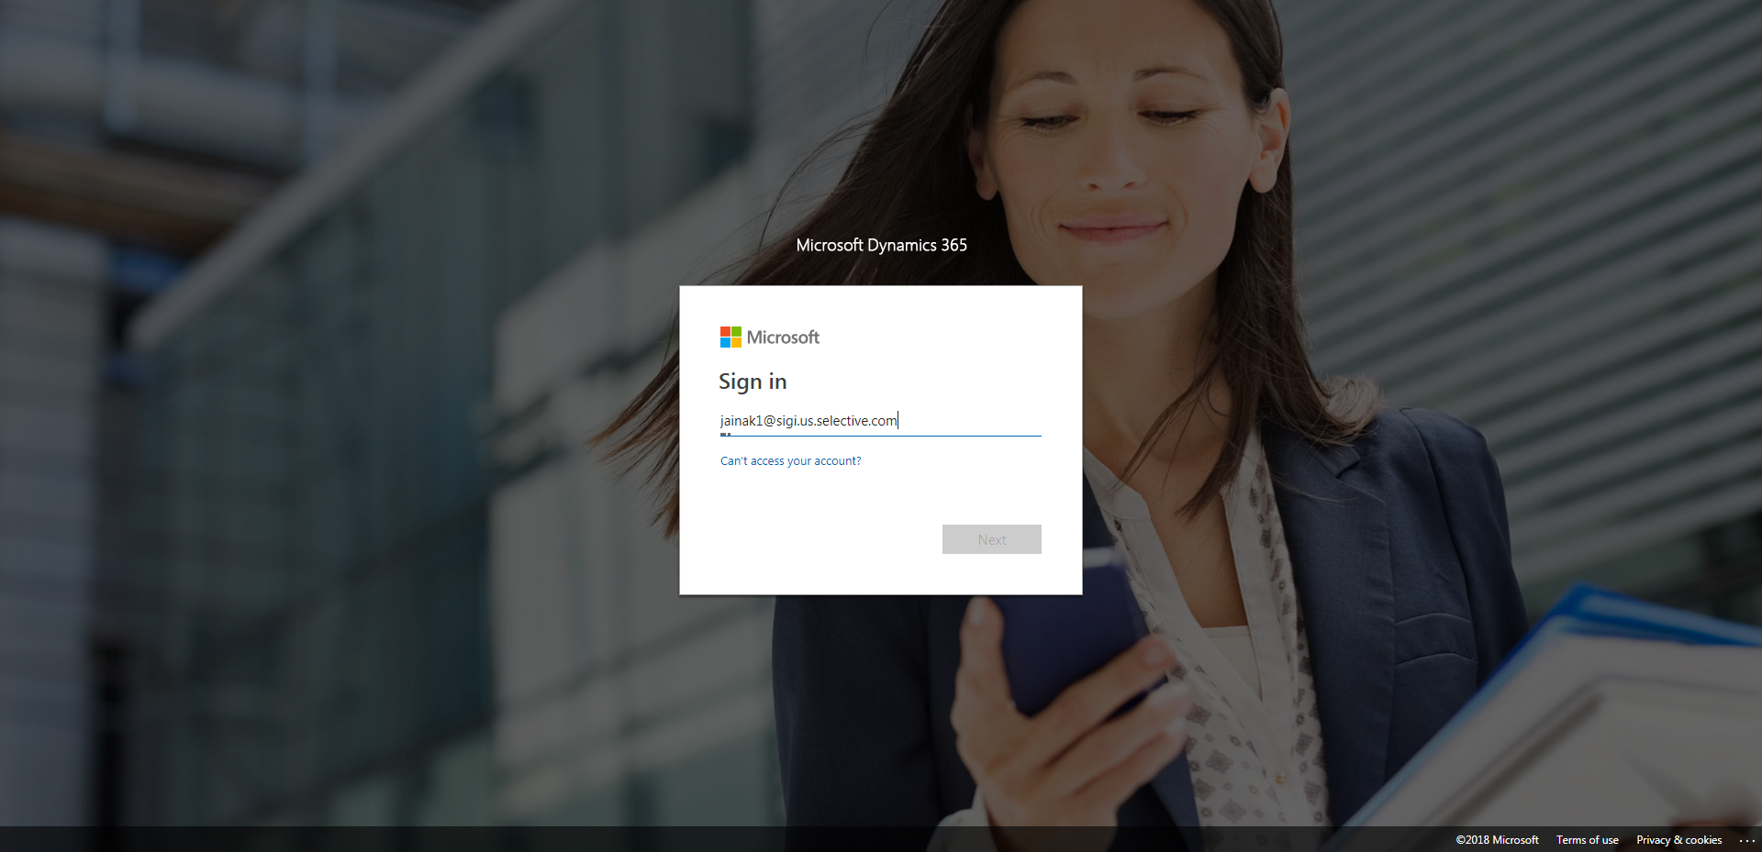

ContactManagement_Verify Contact notes _Instance44_12-Jul-2018_07-47-06_AM_EnterTextAction.png

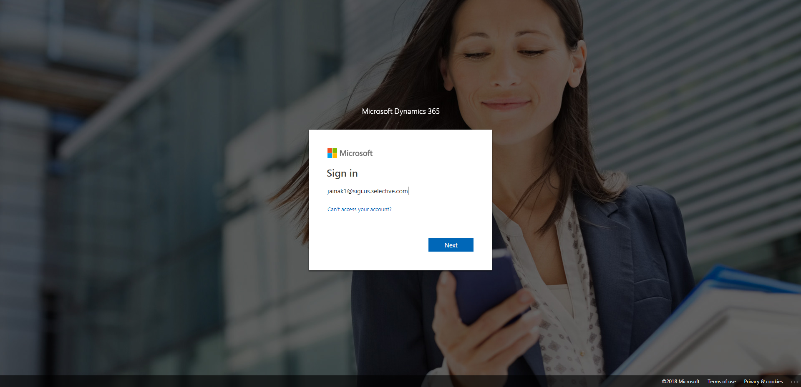

ContactManagement_Verify Contact notes _Instance44_12-Jul-2018_07-47-22_AM_SingleSignOn.png

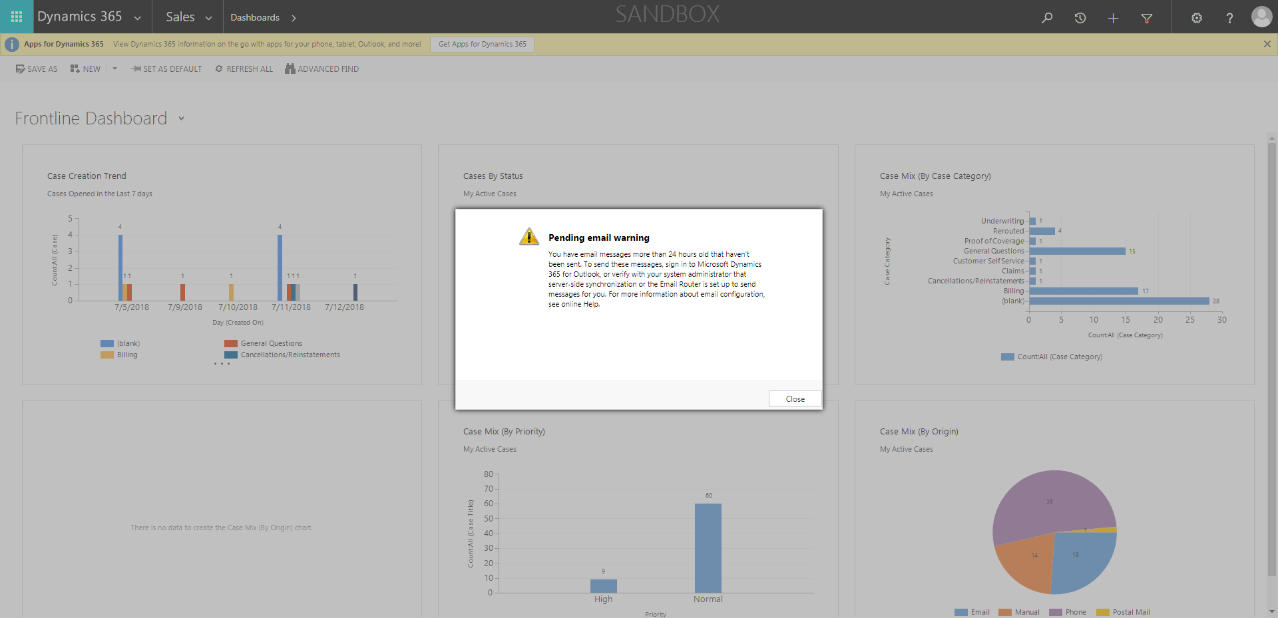

ContactManagement_Verify Contact notes _Instance44_12-Jul-2018_07-47-26_AM_SingleSignOn.png

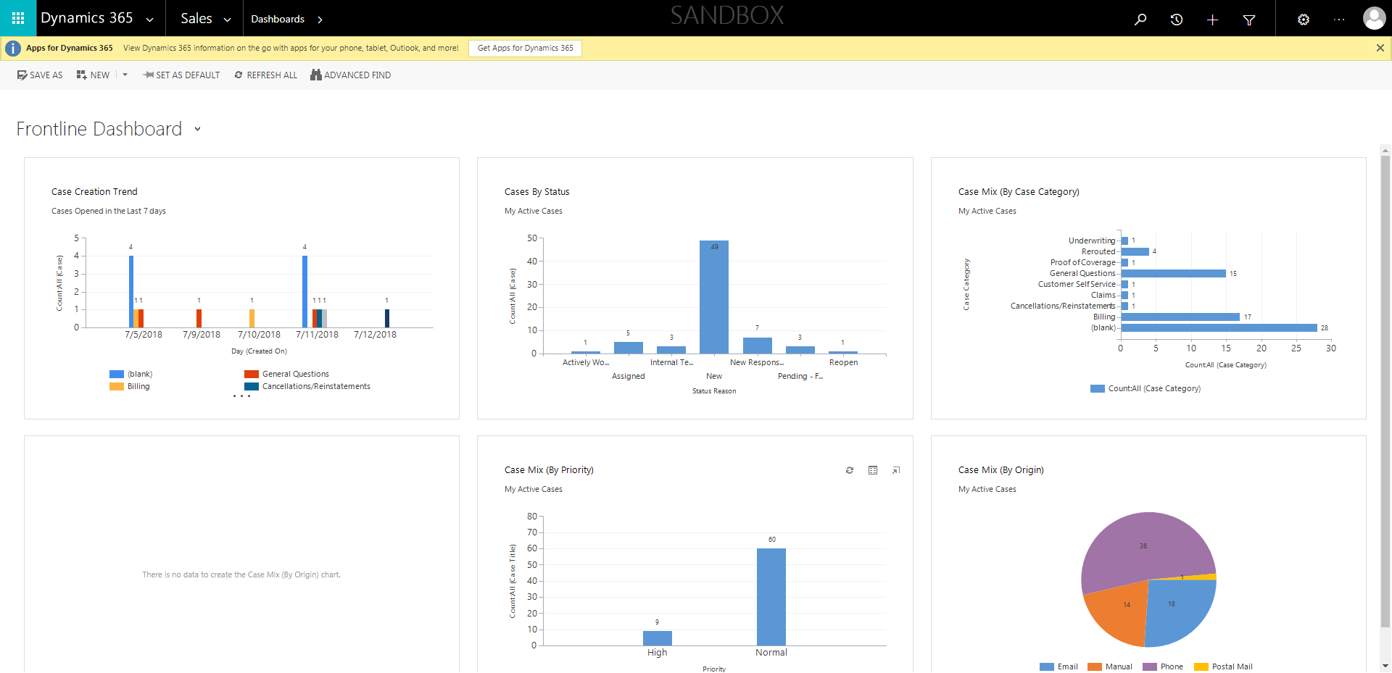

ContactManagement_Verify Contact notes _Instance44_12-Jul-2018_07-48-36_AM_Validatingcontactentitynavigation.png

